**EXPERIMENT-12:**

12.Develop test cases for the above containerized application using selenium

* The pre-requisite for jmeter is java
* Download jmeter from the official website

<https://jmeter.apache.org/download_jmeter.cgi>

* Download the zip file under binaries and extract it ,set path
* Go to bin amd run the jmeter window batch file

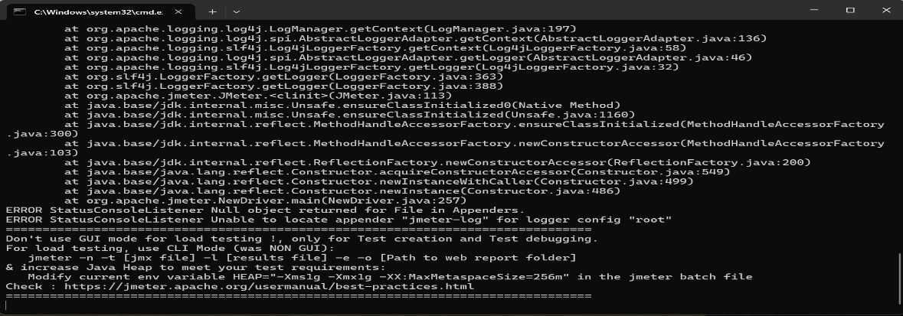



* 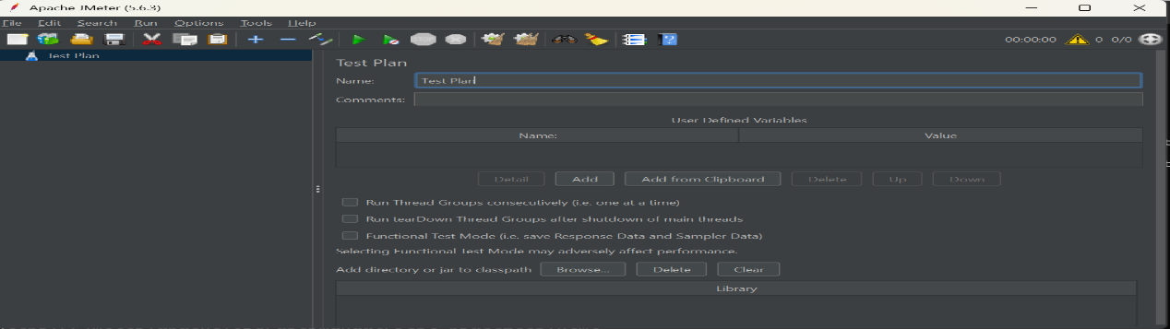Follow the steps to test saispurthi website
* 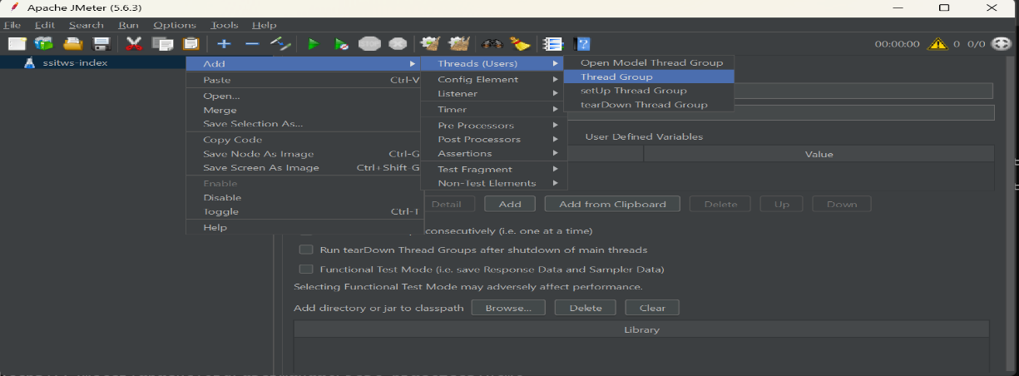Change the name and add thread group
* 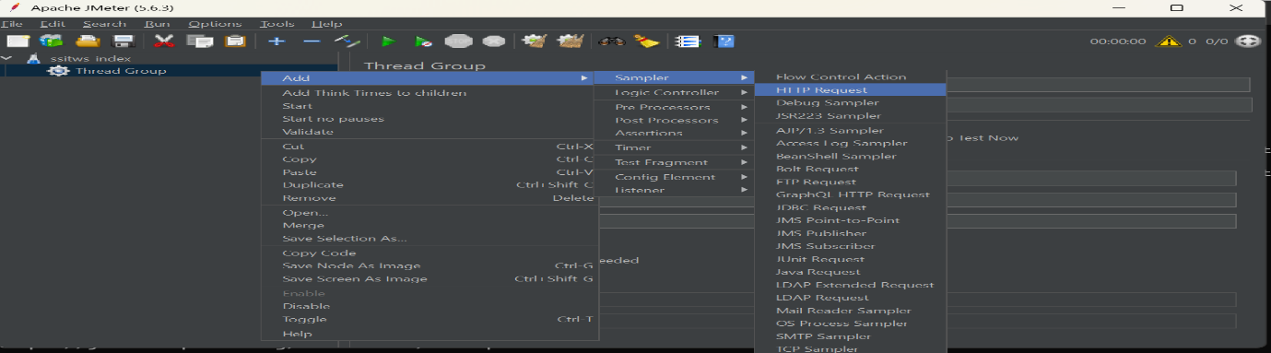In that thread group add HTTP request
* 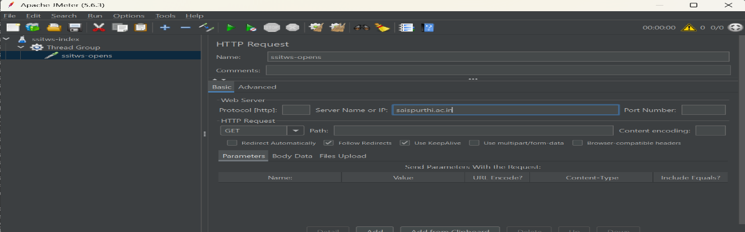Rename the HTTP request and add server name as saispurthi.ac.in
* 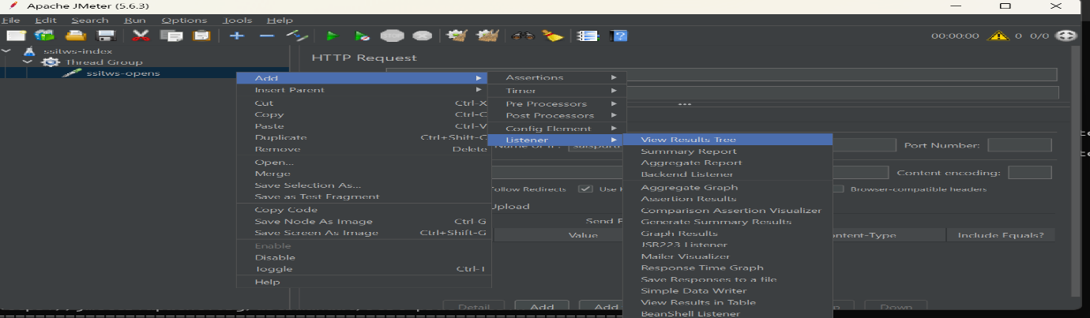Add view results tree
* Add view results in table

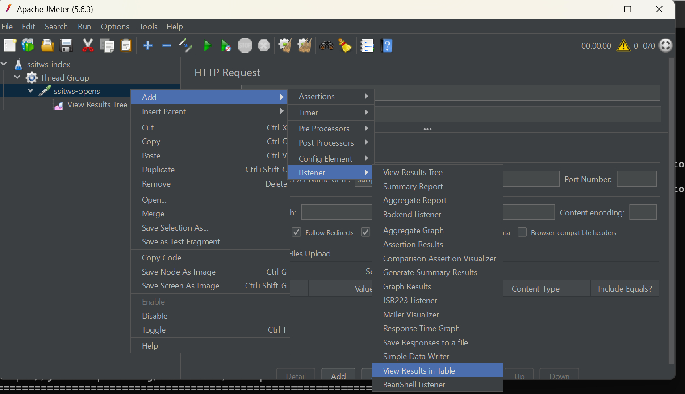

* 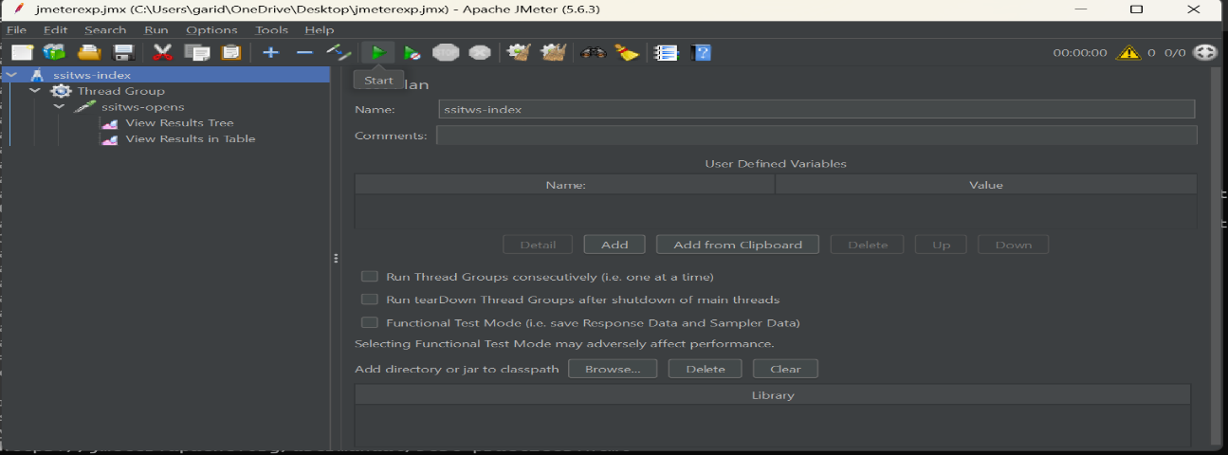Save this and start
* 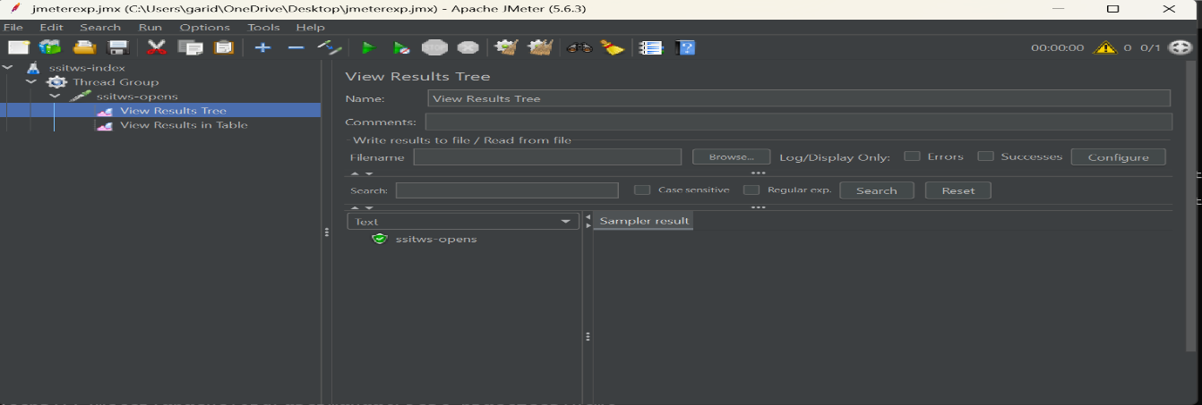We can see view results tree
* We can see view results in table

